|  |  |  |  |  |  |
| --- | --- | --- | --- | --- | --- |
| Date | 28-Nov-22 | | | Tester Name | Janette Paus |
| Environment | Penfax - Test 2 | | | Login used |  |
| Operating System | Windows | Version: 21H2 | Update Number: | | |
| Software Used | Edge | Version: 107.0.1418.56 | Update Number: | | |
| Select Software | Version: | Update Number: | | |
| Application Release version | R22.4.1 | | | | |
| Test Case Title | E 18.01 | | | | |
| Test Type | Regression | | | | |
| Test Scenario | Non-Resident Payment - USA | | | | |
| Expected Results | That the payment will process out of the account to the member and tax deducted according to the non-resident tax rate of 25% for USA | | | | |
| Pass/Fail | Select | | | JIRA# | <enter the new JIRA ticket number if the test case failed> |

Search for member with address in USA, but still has money in PEPP account:

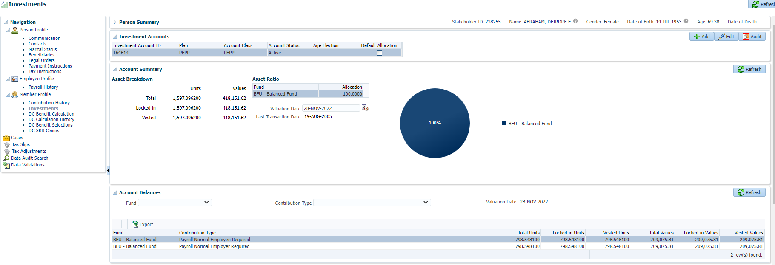

Check to confirm employment period end date (or add end date):

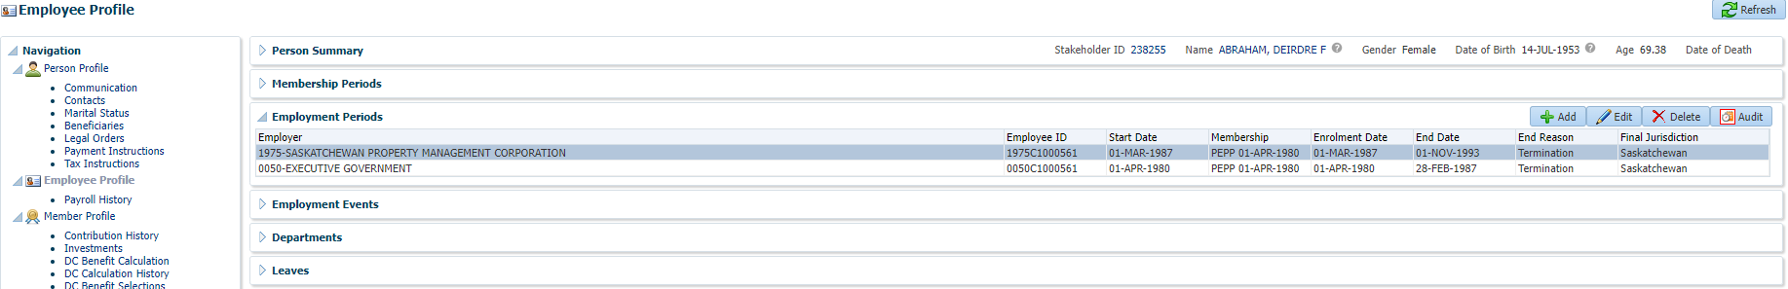

Create DC Benefit Selection, add retirement date (if member is over 50 only), they do qualify if they are under 50 years.

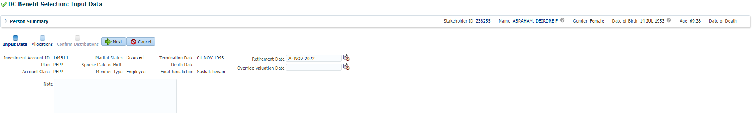

Choose 100% Non-Resident Cash (does not have option for partial non-resident withdrawal) and click Save:

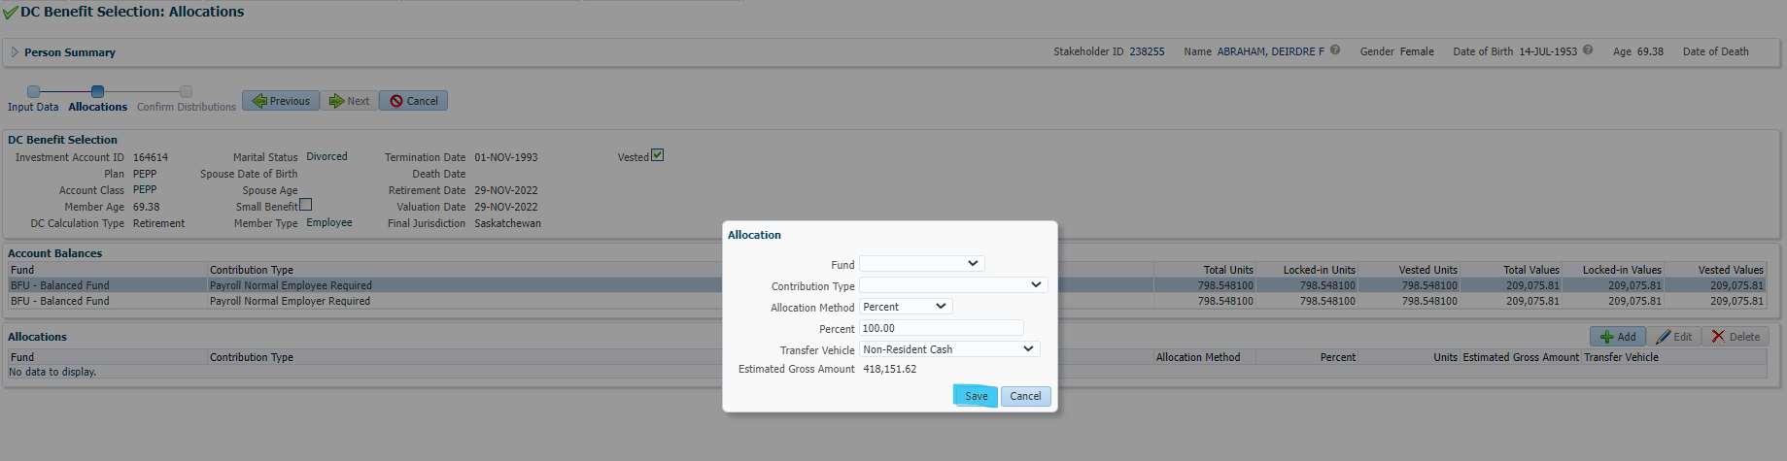

Click Next:

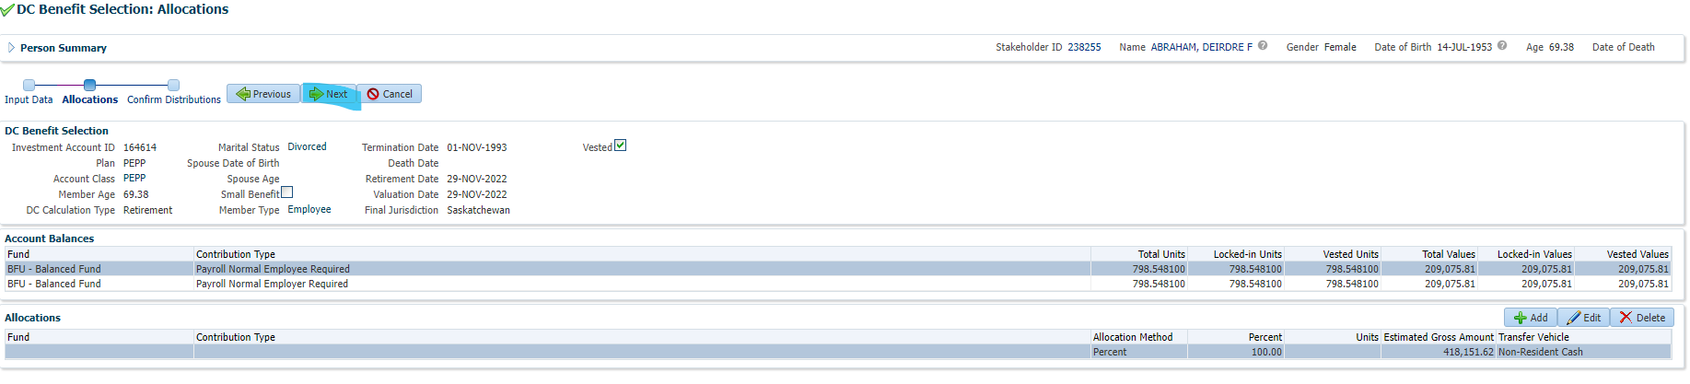

Add new Payment Instruction and click Save:

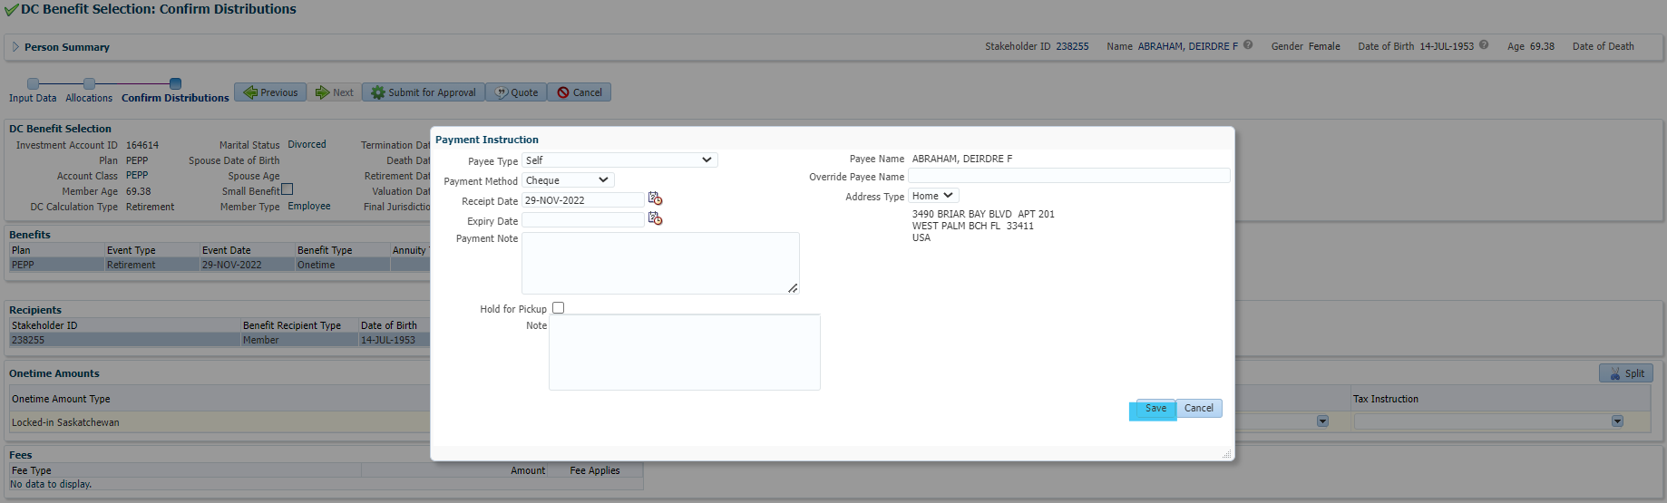

Add new Tax Instruction (just update country) and click Save:

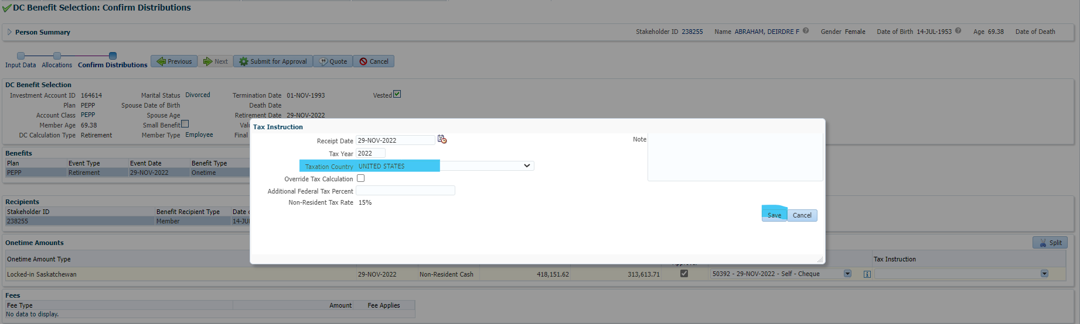

Double check the tax calculation in DC Benefit Selection

(Note: even though the tax instruction shows a rate of 15%, that only applies to VPB payments less than 100%, the rate for non-residents should always be 25%)

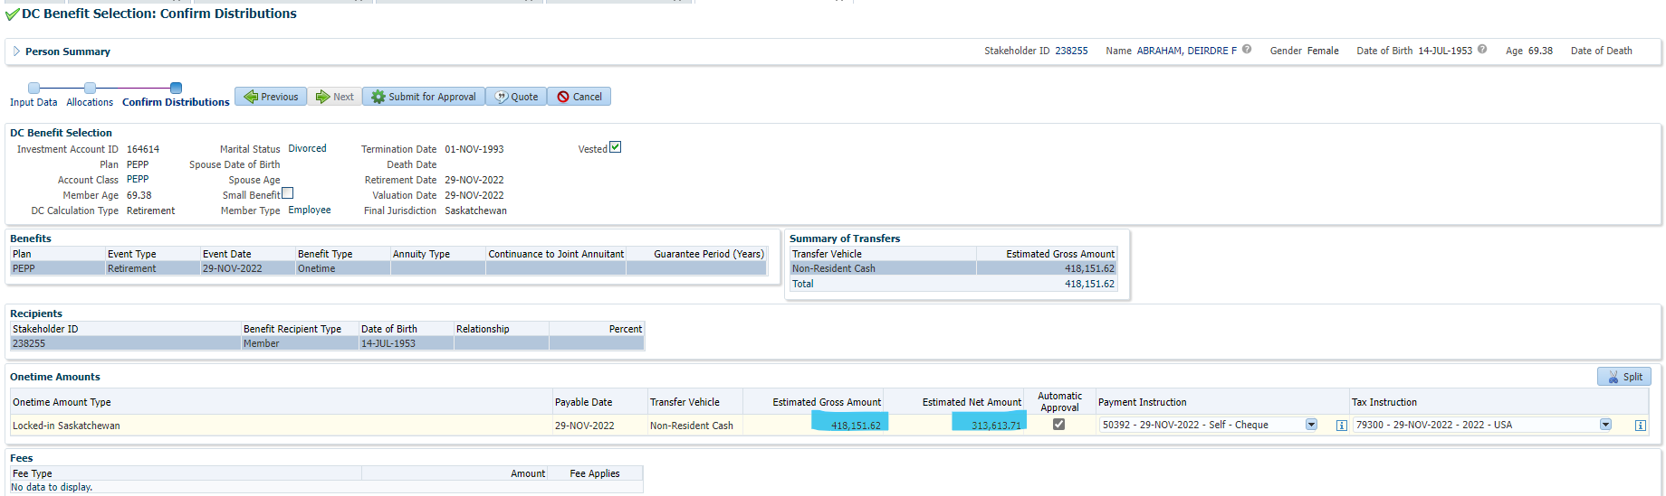

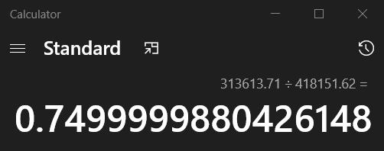

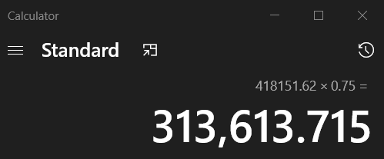

Submit for approval and approve:

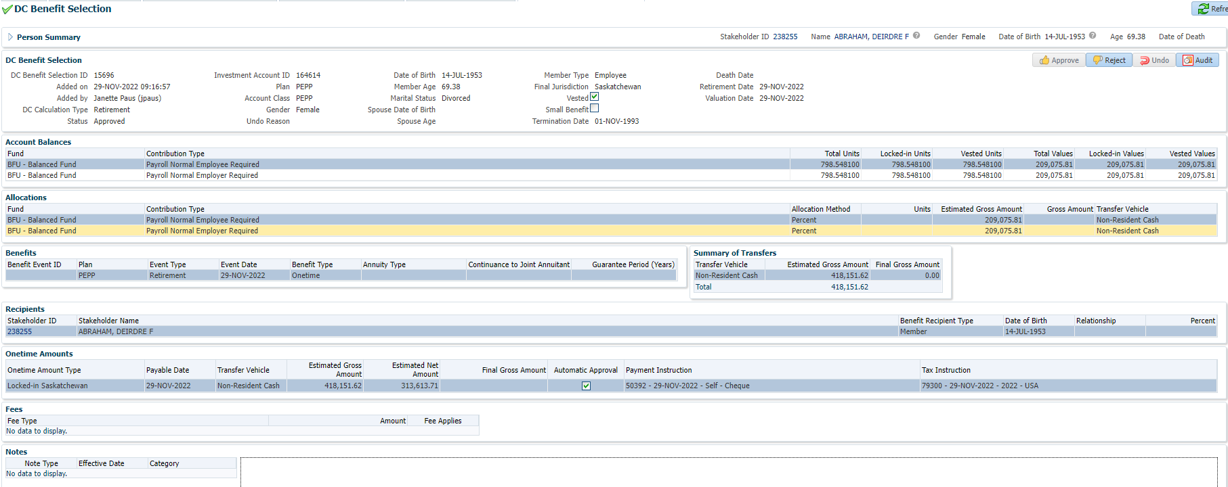

Confirm next day that the funds were withdrawn and payment processed:

Tax correct and payment paid via cheque #